Chapter 3, Solution 47

First, transform the current sources as shown below.

- 6V +
2

I₃
V₁ 8 V₂ 4 V₃

4
8
I₁ 2 I₂
+ +
20V 12V
- -

For mesh 1,

(1)
For mesh 2,

(2)
For mesh 3,

(3)
Putting (1) to (3) in matrix form, we obtain

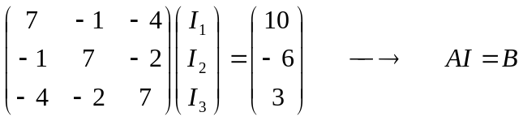
Using MATLAB,

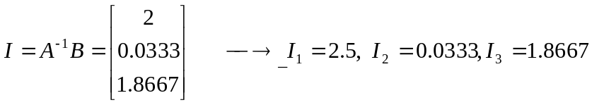
But
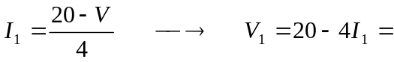10 V

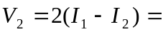4.933 V

Also,
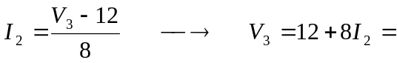 12.267 V.

